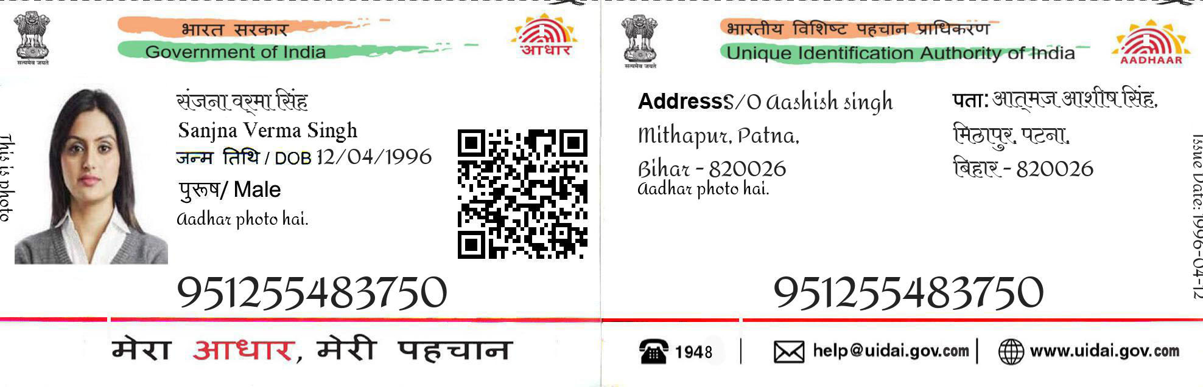

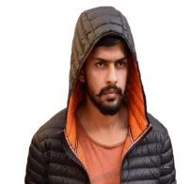

Lawrence Bishnoi

DOB 12/02/1993

Male

9319 XXXX XXXX

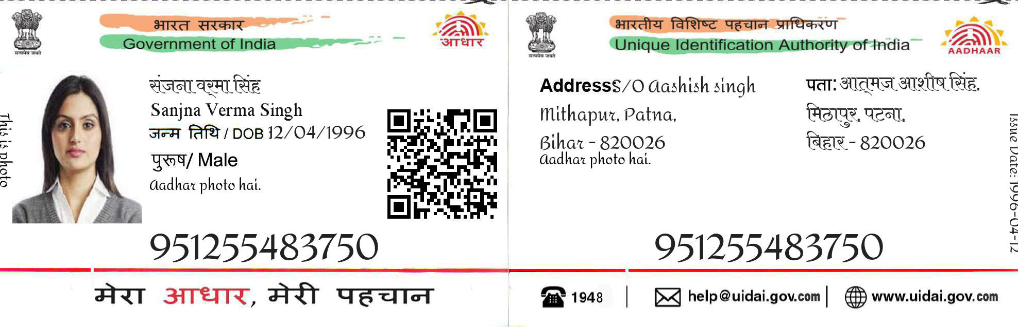



Address/Bishnoi house, Dutarawali in Fazilka district Punjab-1521116

Address/Bishnoi house, Dutarawali in Fazilka district Punjab-1521116

9319 XXXX XXXX

